A Study on Privacy and Security Provided by APPLE
A
PROJECT-BASED LEARNING REPORT

SAGE University, Bhopal
For the partial fulfillment of

Bachelor of Business Administration
SEM -3 (2022-2023)

Submitted by Guided By
1. Aradhna Barve Ms. Charul Chaturvedi
21BBA3PLN10005 ( ) (Assistant Professor)
2. Abhishek Saini School of Management
21BBA3ITM10001 ( )
3. Ananya Singh Mrs. Saloni Sharma
21BBA3ITM10005 ( ) (Assistant Professor)
4. Sujal Ahirwar School of Management
21BBA3BAF10024 ( )

---------------------------------------------------------------------------------
School of Management, SAGE University, Bhopal Sahara Bypass Road, Katara Hills, Extension, Bhopal, Madhya Pradesh 462022

DECLARATION

Aradhna Barve (21BBA3PLN10005), Abhishek Saini (21BBA3ITM10001), Ananya Singh (21BBA3ITM10005), Sujal Ahirwar (21BBA3BAF10024), students of School of Management, SAGE University, Bhopal (M.P.) do hereby declare that Project Based Learning –I entitled “A study on user-generated content, according to viewer’s interest-based content (YOUTUBE)” is an original work and has not been submitted anywhere in the quest of any degree.

Date: ………………… 1.Aradhna Barve
(21BBA3PLN10005)
( )
Place: ………………... 2. Abhishek Saini
(21BBA3ITM10001)
( )
3 . Ananya Singh
(21BBA3ITM10005)
( )
4 . Sujal Ahirwar
(21BBA3BAF10024)
( )

CERTIFICATE

This is to certify that, Aradhna Barve(21BBA3PLN10005), Abhishek Saini (21BBA3ITM10001), Ananya Singh(21BBA3ITM10005), Sujal Ahirwar(21BBA3BAF10024), are the students of BBA Semester – III. They have prepared Project Based Learning – III under my guidance entitled. A study on user-generated content, according to viewer’s interest-based content (YOUTUBE).

( ) ( )
Mrs. Saloni Sharma Ms. Charul Chaturvedi
School of Management (Assistant Professor)
SAGE UNIVERSITY School of Management
BHOPAL SAGE UNIVERSITY
BHOPAL
Date- ___________
Place-___________

ACKNOWLEDGEMENT

In completing this project, many people helped me. We would like to thank all those who are related to this project.
Primarily, we would thank God for being able to complete this project with success. We would like to express our special thanks of gratitude to my teacher Ms. Charul Chaturvedi who gave me the golden opportunity to do this project on the topic. A study on user-generated content, according to viewer’s interest-based content (YOUTUBE). It helped me in doing a lot of Research and We came to know about a lot of things related to this topic. His suggestions and directions have helped in the completion of this project.
Finally, we would like to thank my parents and friends who have helped me with their valuable suggestions and guidance and have been very helpful in various stages of project completion.

Date: ………………… 1. Aradhna Barve
(21BBA3PLN10005)
( )
Place: ………………... 2. Abhishek Saini
(21BBA3ITM10001)
( )
3. Ananya Singh
(21BBA3PLN10005)
( )
4. Sujal Ahirwar
(21BBA3BAF10024)
( )

TABLE OF CONTENTS

Page No.
- Introduction [5]
  - About YouTube [5-7]
    - About copyright
    - Categories of YouTube
    - YouTube features
  - Users and their content
    - What is user-generated content?
    - Contents
- Review of Literature [8]
- Objectives [9]
- Research Methodology [9]
  - Research method
- Data analysis and interpretation [9]
  - Data source
    - Primary data
    - Secondary data
  - The tools
    - Tools for Collection of data
  - Limitations
- Conclusion and Implications [10]
- Questionnaire selection and validation [11-14]
- Reference [15]

1 Introduction
1.1 About YouTube
YouTube is the Web site for sharing videos. It was registered on February 14, 2005, by Steve Chen, Chad Hurley, and Jawed Karim, three former employees of the American e-commerce company PayPal. They had the idea that ordinary people would enjoy sharing their “home videos.” The company is headquartered in San Bruno, California.

Shortly after the site opened on a limited (“beta”) basis in May 2005, it was attracting some 30,000 visitors per day. By the time YouTube was officially launched on December 15, 2005, it was serving more than two million video views each day. By January 2006 that number had increased to more than 25 million views. The number of videos available on the site surpassed 25 million in March 2006, with more than 20,000 new videos uploaded daily. By the summer of 2006, YouTube was serving more than 100 million videos per day, and the number of videos being uploaded to the site showed no sign of slowing down.

1.1.1 About Copy right

The company continually had to purchase more computer equipment and broadband Internet connections. In addition, YouTube was forced to allocate more financial resources for potential litigation, as many media companies discovered that some of the videos uploaded to YouTube contained copyrighted material. With limited success in commercializing its Web site or containing its growing costs, YouTube began looking for a buyer.

In 2005 the American search engine company Google Inc. launched a video service, Google Video, but it failed to generate much traffic, and Google was prompted to purchase YouTube for $1.65 billion in stock in November 2006. Rather than merging the Web sites, however, Google continued YouTube’s operation as before. To reduce the risk of copyright-infringement lawsuits, Google negotiated deals with several entertainment companies that would allow copyrighted video material to appear on YouTube and would give YouTube users the right to include certain copyrighted songs in their videos. It also agreed to remove tens of thousands of copyrighted video files from YouTube.

1.1.2 Categories of content on YouTube

- Commentary video - A commentary video usually has a person in front of the camera, providing their honest opinion on a specific subject (trending at the moment). The types of commentary videos can vary, with the most common ones being a reaction, vlogs, conspiracies, and topics.

- Music video - Many music streaming services and apps have flourished lately, nothing seems to replace YT clips. These are not limited to the creations directly promoted by the artists themselves. There’s also a huge amount of user-generated and amateur content, cover performances, lyrics, karaoke material, etc. Plus, the platform allows organizing multiple videos within personalized playlists.

E.g. - best YouTube channel in music video t-series, best YouTuber Taylor swift

- Tutorials and Educational Videos - tutorial videos seem to be a very sound methodology. So much so that some of them are elaborated enough to be labeled as educational videos. Can one study through YouTube? The answer is still open to debate. However, online learning keeps growing in importance.

E.g. - Crash Course 14.1M subscribers and TED-Ed 17.8M subscriber

- Documentaries and Docuseries - documentaries that are filmed in several episodes They typically follow an individual, a group of people, or a certain situation over a certain period. YouTube documentaries may have various objectives, from common knowledge to marketing (say, companies that film their day-to-day functioning).

E.g. - National Geographic | Science, Exploration, And Adventure 20.8M subscribers
Timeline - World History Documentaries 4.4M subscribers

- Gaming Videos – the most coveted YouTube category, especially by youngsters. The video game industry keeps rolling with inexorable progress, coming in more and more shapes and sizes. What we usually see in those YouTube videos is one or several gamers playing a game and commenting on it. They offer a real-time experience to the spectators, almost like a social event where some friends gather together. Some of the channels are exclusively dedicated to one particular game or brand. Some others act like phenomenon boosters, turning their owner into celebrities.

E.g. - Jacksepticeye 29M subscribers and Techno Gamer 30M subscriber

- Storytelling - Very classical forms immediately come to mind, like stories for children. But not only that. YouTube channels serve as audiobook libraries for various groups of individuals. Their videos often include infographics and animations. The topics can be extremely varied. Within this same category, we also have success stories. These usually follow the journey of entrepreneurs or any other people who have accomplished certain goals.

- Challenges - Funny or embarrassing, it doesn’t seem to matter, judging from the number of people who love these videos. Simply put, challenges are a sort of game in which the participants are invited to do out-of-the-ordinary activities.

E.g. - MrBeast 111M subscribers

1.1.3 YouTube features

  - Users can search for and watch videos
  - Create a personal YouTube channel
  - Upload videos to your channel
  - Like/Comment/share other YouTube videos
  - Users can subscribe/follow other YouTube channels and users
  - Create playlists to organize videos and group videos together

1.2 Users and their content

1.2.1 What is user-generated content?

User-generated content (also known as UGC or consumer-generated content) is original, brand-specific content created by customers and published on social media or other channels. UGC comes in many forms, including images, videos, reviews, a testimonial, or even a podcast

    - Contents

Contents are based on categories. Different contents can create or can be divided into different categories. Users can be content creators or can be a viewer. Varieties of content for different people. Creators who create the most relatable content can get more views. YouTubers / content creators can earn through YouTube if they gain consistency in viewers and subscribers.
- Review of Literature

- According to Teresa Naab, (Universität Mannheim) and Annika Sehl, (Katholische Universität Eichstätt-Ingolstadt) (Oct 2016) researched that:-
A review of communication research on user-generated content with a special focus on studies that include a content analysis. The trends of research on this comparatively new and rapidly developing subject are systematically discussed and desiderata are identified. The evaluation is based on a content analysis of pertinent approaches in nine relevant international peer-reviewed journals published from 2004 to 2012. From the results, the article concludes that user-generated content is approached by scholars from a variety of perspectives and offers scope for interdisciplinary cooperation but also notes that several of the challenges posed by the continuously changing nature of the content are not fully met.

- According to S. Gayathri and Dr. A. S. Saranya on July 2020 (Ethiraj college for women, Chennai)

Social media has significantly changed the relationship between the manufacturer of the product and the consumer. Today, consumers rely more on the reviews, suggestions, and information that other users generate on social media (e.g., on YouTube) than product advertisements. The current study examined the influence of the number of posts, views, and reviews on the perceived credibility and usefulness of the product content, that users generate on YouTube. Results revealed that the number of posts, views, and reviews have a positive effect on consumers’ perceived credibility and usefulness of product content on YouTube. In addition, results showed that both perceived credibility and usefulness have a positive relationship with consumer attitudes and behavior ward the product content that other users generate on YouTube. However, the impact of UGC on purchase intention has not emerged as signific concerning QPVR, PC, PU, and AT.

- According to Lucila Dughera and Fernando R. A. Bordignon on Feburary 2021 (Esteban Azzara)

They consider that the study of the YouTube platform and its relation with the teaching and learning practices is a type of “thermometer” that will allow us to understand at firsthand some of the factors undergoing tension in the educational system that is also affecting young people’s trajectories. All in all, we consider that this research might provide the knowledge to build bridges connecting the inside and outside of the classroom in a dialogue to improve those educational trajectories.

- According to Norlidah Alias , Siti Hajar Abd Razak and group on 2013( Kuala Lumpur, Malaysia )
YouTube articles related only started to be studied of late, by 2012. This study could be affected by the setting of the studies based on their research topics, issues category, research settings and sampling, research design, research method and data analysis. Furthermore, there will never be a fit finding on the same issues researched, and further studies always are needed to fill in the gaps between the last and the current studies. The frequency studying of YouTube has increases in the current issues (2013). The study of YouTube can attract other researchers and will give more results besides affecting our educational system.
- Objectives

  - To know about the content that users make
  - To know about fake promotional videos and real videos
  - To know the most-watched category video in you tube
  - To check if the viewers are aware of bad influencers or fake influencers

- Researcher Methodology

4.1 RESEARCH METHOD:
The strategies, processes, or techniques utilized in the collection of data or evidence for analysis in order to uncover new information or create a better understanding of a topic.

- DATA COLLECTION METHOD: We have used the survey method with the help of Google forms for data collection. The survey is the most commonly used method and gives you some approximate results as well.
The questionnaire contains some questions like:
The age group, gender, what’s your preferences, frequent use of customers, prefer the same drinks or not, etc.
  - DATA SOURCE:
    - Primary Data: The current research was conducted in Bhopal city from December 2022 to January 2023 using questionnaires shared with the consumer. We have received 60 responses which are slightly great according to our expectations which 50 - 60.
    - Secondary Data: we have collected secondary data from some literature that have already been published in the form of research paper, articles, and reports. Material available on different websites is also considered.
  - THE TOOLS
    - Tools for collection of data: We used to google forms for a survey and prepared a questionnaire for the collection of data from the crowd.
  - Limitation
    - Limited access to data.
    - Lack of previous research study
    - The data we grabbed from the previous research paper was not updated as per research scenario.
    - Sample size depends on the nature of the research problem.
- Conclusion and implication

By our research, we found out that most people have accounts on YouTube. There biggest problem while watching contents on YouTube are advertisements which bugs their videos. You tube is mainly accessed in evening by 20-22 yrs people. Yet some people are not aware about fake promotions, or fake content creators. You tube work as a source giver for almost every type of things. In previous, research we have found that previously technology and nearby things were changing rapidly due to which new contents were changing very fast and was confusing the audience. Secondly influencers behaviour was the major thing which was interacting peoples. Thirdly, YouTube is providing both outside and inside classroom contents which means YouTube is offering wide range of information. And last fourth, in 2013s YouTube was mainly used for informative purpose.

- Questionnaire selection and validation
The current research was conducted in Bhopal city in December 2022 to January 2023 using questionnaires shared with the consumers. We have received 60 responses which is slightly great according to our expectations.
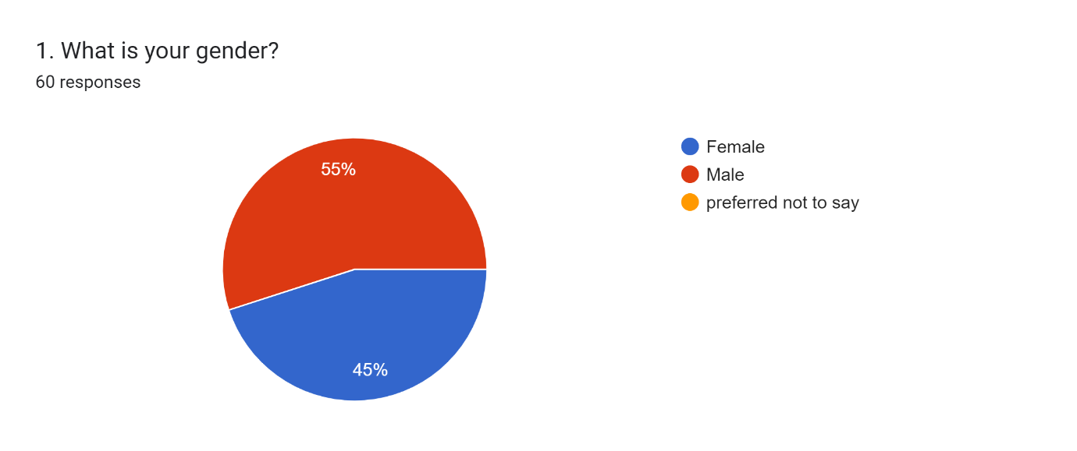
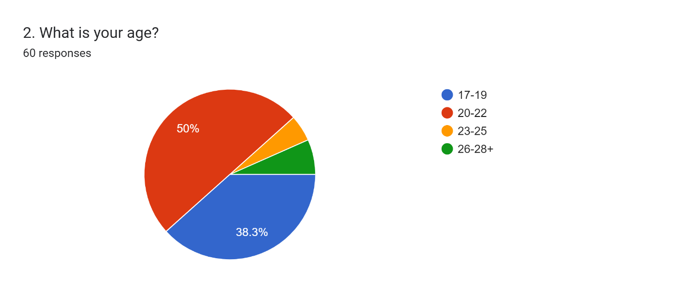
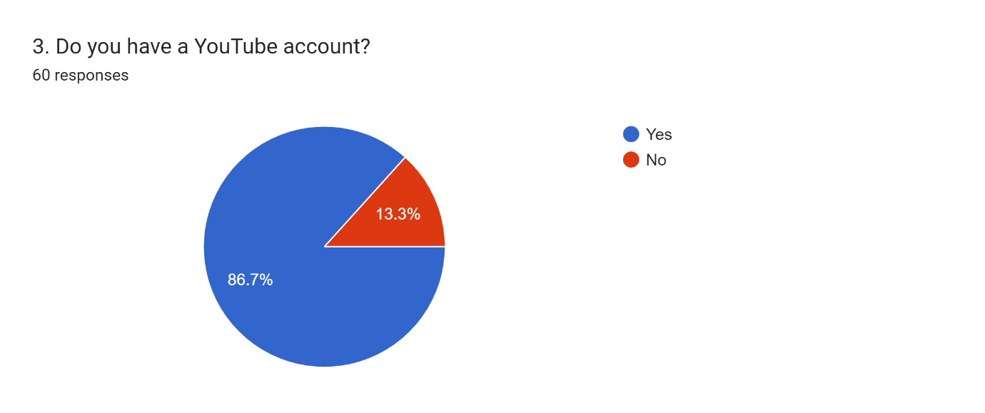

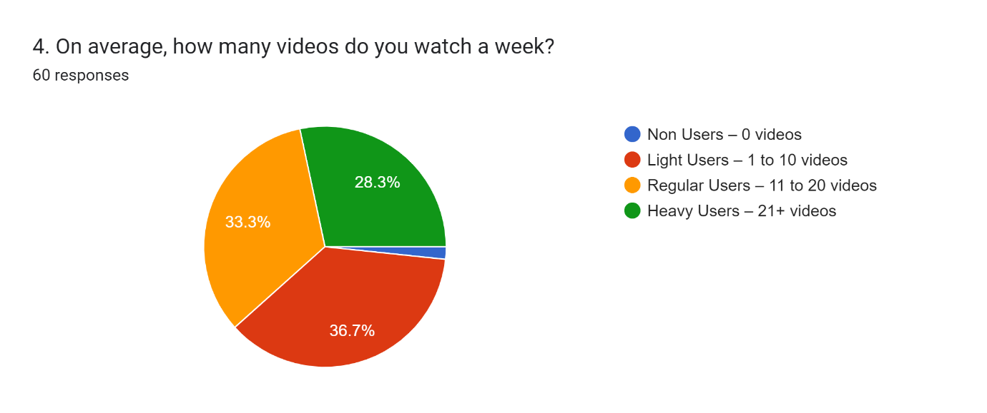
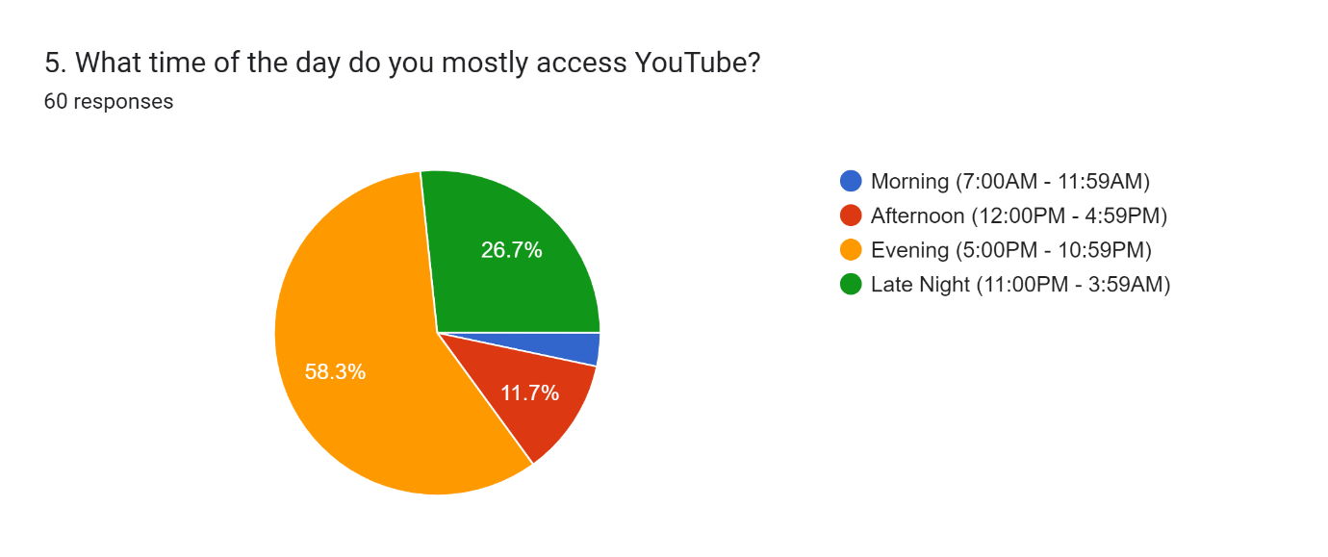
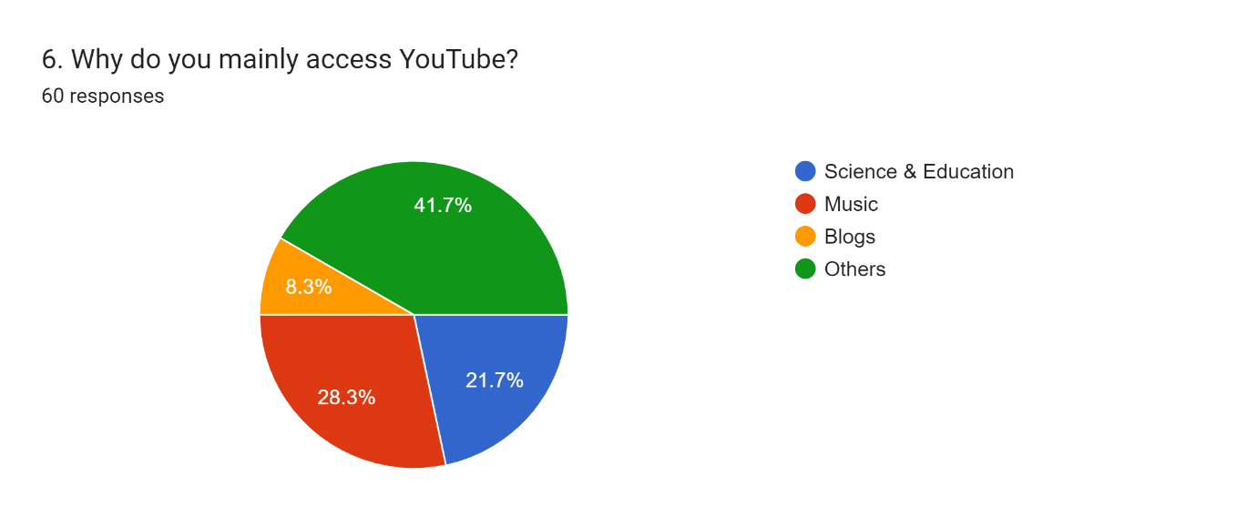
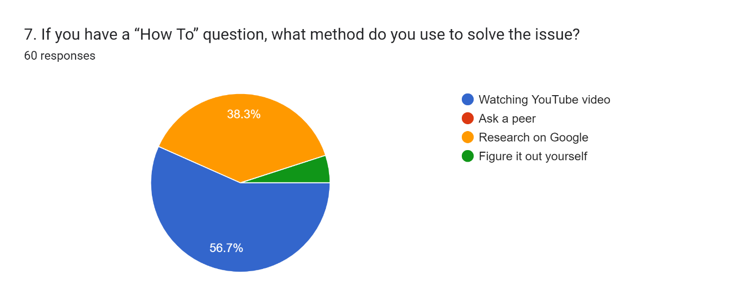
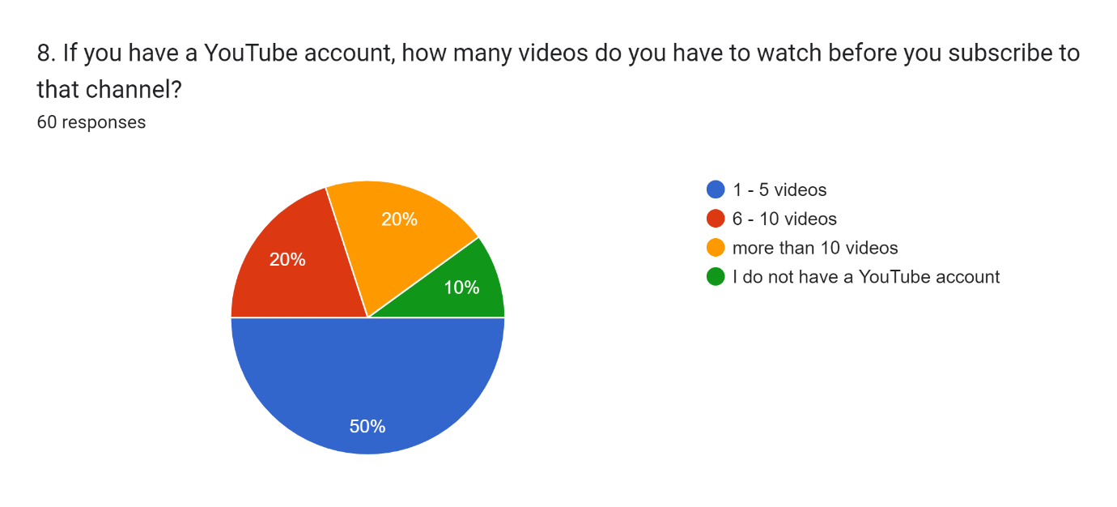
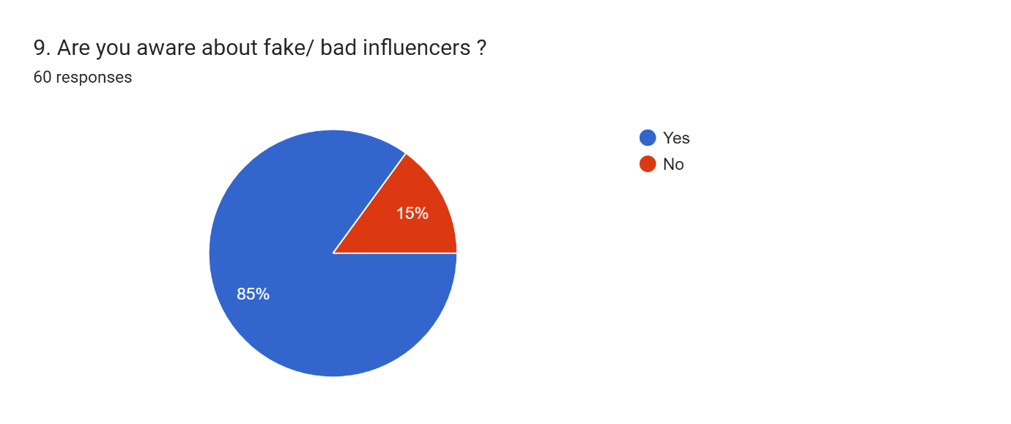
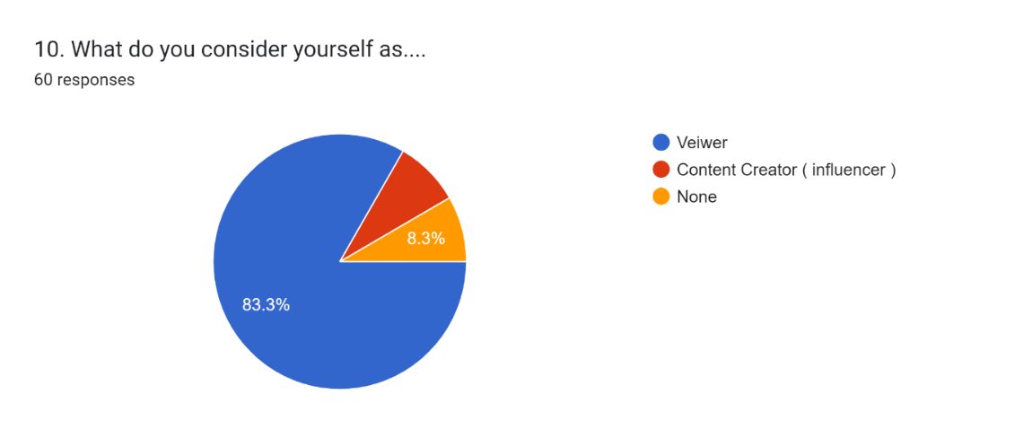
11) How does YouTube influence your life?

12) Anything or any suggestion regarding YouTube

- Reference
  - https://www.researchgate.net/publication/349350098_A_literature_review_of_the_YouTube_phenomenon_and_the_teaching_and_learning_practices
  - https://www.researchgate.net/publication/342664667_USER_GENERATED_CONTENT_AND_YOU_TUBE
  - https://www.dopinger.com/blog/popular-youtube-categories#Music_Videos
  - https://www.google.com/search?q=youtube+features&rlz=1C1CHBF_enIN1015IN1015&oq=you+tube+feat&aqs=chrome.1.69i57j0i10i131i433i512j0i10i512l8.6663j0j7&sourceid=chrome&ie=UTF-8
  - https://www.webwise.ie/parents/what-is-youtube/
  - https://www.dopinger.com/blog/popular-youtube-categories
  - https://www.google.com/search?q=categories+in+youtube&rlz=1C1CHBF_enIN1015IN1015&oq=categories+in+y&aqs=chrome.1.69i57j0i512l2j0i22i30l6j0i15i22i30.8576j0j7&sourceid=chrome&ie=UTF-8
  - https://mail.google.com/mail/u/0/?tab=rm&ogbl#inbox
  - www.googlescholar.com
  - https://www.google.com/search?q=ethiraj+college+for+women&rlz=1C1CHBF_enIN1015IN1015&oq=ethiraj+college+for+women&aqs=chrome.0.0i355i512j46i512j0i512l2.1831j0j7&sourceid=chrome&ie=UTF-8
  - https://forms.gle/LnZRogsLJE4wRzY49

